BNC TO HDMI CONVERTER
USER MANUAL
If you need to replace expensive LCD video
monitor by normal LCD, or you need to convert BNC signal to HDMI signal, this BNC to HDMI video converter will be your best choice. This converter is an economic, effective and perfect solution for lossless video conversion.
- Package details
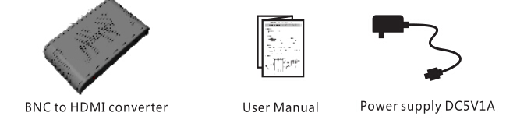
2、Devices requirements
①. Cameras with BNC input or other BNC devices
②. TV or projector with HDMI input
3、I nstallation:
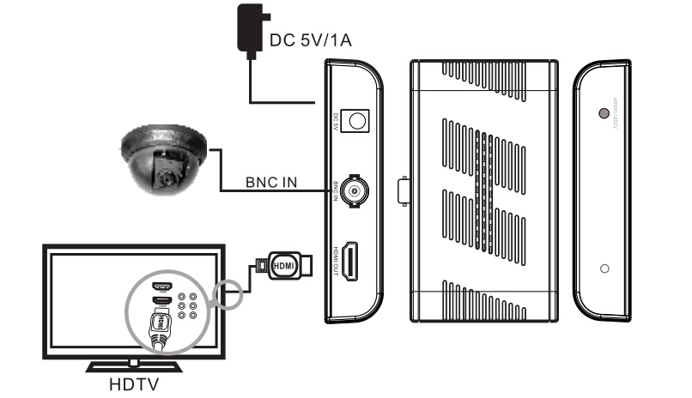
①. Connect the BNC source to the converter with
BNC cable
②. Connect the converter to HDTV with HDMI
cable. Power it on and adjust HDTV to the
corresponding HDMI channel.
4. Operation：
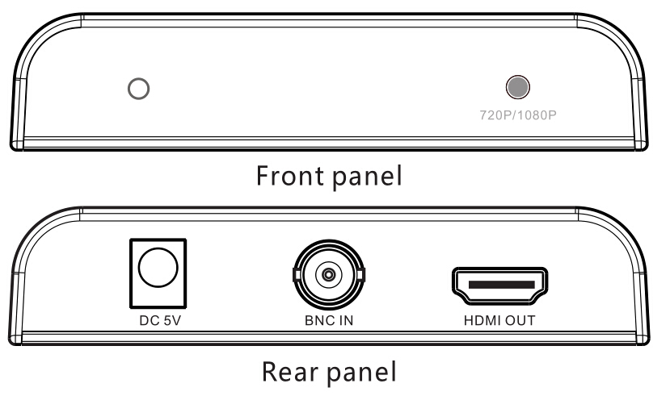
①.720P/1080P: Press to choose output HDMI
signal as 720P@50Hz,1080P@50Hz,720P@60Hz,
1080P@60Hz
LED is red when output 720P, greenwhen output
1080P.
②. Long press 720P/1080P button for 3 seconds to
switch between 4:3 and 16:9 etc mode.
5.Trouble shooting：
Q: No image output?
A: 1)Check and make sure all the connection is
correct, signal LED indicator lights up and
HDTV channel is chosen correctly.
2)Check whether TV supports to output HDMI
signal format
6. Technical parameter：
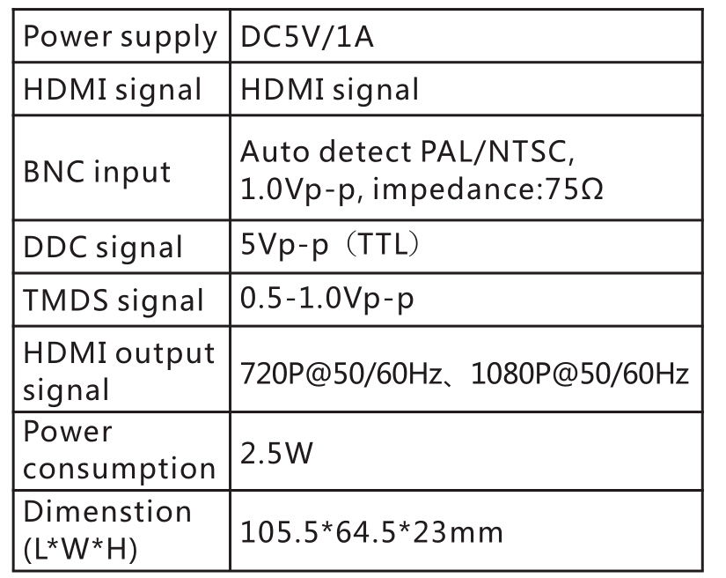
IMPORTANT SAFETY NOTICE
1. Do not plug and unplug devices with power on.
2. Install it in a ventilated dry place.
3. Use DC5V power supply only. Make sure
specification matched if using adapters not
supplied by factory.

